Twin Cities Jazz Workshop Student Registration Form
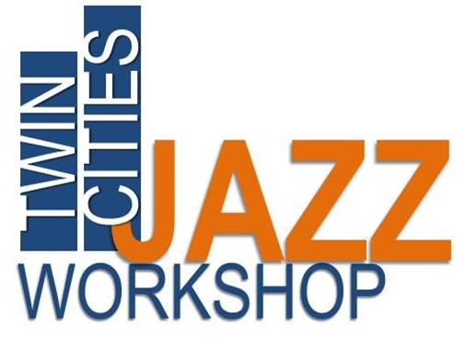
Print form and mail to jazz workshop address at bottom of form
Receive $10 discount off total tuition by registering BEFORE May 1st
Tuition: $235 for 1 session,
$430 for 2 sessions ($40 discount),
All applicants must include $60 of total tuition fee with registration form

Contact Information
Email Address
Student Name
Parents/Guardian
Instrument
Years Studied
Street Address
City
State
Telephone(s)
School
Age
TShirt size
(sm, med, lg, x-lg)

Workshop Session(s)

For which Workshop sessions would you like to enroll?
Top of Form
SUMMER July 27th to 31st MORNING  Mon-Fri (9:45 a.m. to 12:45 p.m.) | SUMMER July 27th to 31st AFTERNOON  Mon-Fri (2 p.m. to 5 p.m.)
SUMMER August 3rd to 7th MORNING  Mon-Fri (9:45 a.m. to 12:45 p.m.) | SUMMER August 3rd to 7th AFTERNOON  Mon-Fri (2 p.m. to 5 p.m.)
FALL Oct 3rd to Nov 14th WEEKLY  Saturdays (1:00 p.m. to 3:00 p.m.) | FALL Oct 3rd to Nov 14th WEEKLY  Saturdays (1:00 p.m. to 3:00 p.m.)

Experience

Please describe your past studies or experience with jazz or other musical styles:

